Management 390 Industrial Condition Analysis

Reading

The five competitive forces that shape strategy

* Five forces
  + Bargaining power of suppliers
  + Threat of new entrance
  + Threat of substitute products or services
  + Bargaining power of buyers
  + Rivalry among existing competitors (central force)
* If the forces are intense, almost no company earns attractive returns on investment
* If the forces re benign, many companies are profitable
* Industry structure drives competition and profitability
* While a myriad of factors can affect industry profitability in the short run, industry structure manifested in the competitive forces, sets industry profitability in the medium and long run

Forces that shape competition

* The configuration of the five forces differs by industry
* The strongest competitive force or forces determine the profitability of an industry and become the most important to strategy formulation
* The most salient force is not always obvious

Threat of entry

* New entrants to an industry bring new capacity and a desire to gain market share that put pressure on prices, costs, and the rate of investment necessary to compete
* When the threat is high, incumbents must hold down their prices or boost investment to deter new competitors
* The threat of entry in an industry depends on the height of entry barriers that are present and on the reaction entrants can expect form incumbents
* Customer switching costs
  + Switching costs are fixed costs that buyers face when they change suppliers
* Barriers to entry
  + - Supply-side economies of scale
      * Supply-side scale economies deter entry by forcing the aspiring entrant either to come into the industry on a large scale, which requires dislodging entrenched competitors, or to accept a cost disadvantage
    - Demand-side benefits of scale
      * Network effects
        + Arise in industries where a buyer’s willingness to pay for a company’s product increases with the number of other buyers who also patronize the company
    - Capital requirement
      * The need to invest large financial resources in order to compete can deter new entrants
    - Incumbency advantages independent of size
      * No matter what their size, incumbents may have cost or quality advantages not available to potential rivals
    - Unequal access to distribution channels
    - Restrictive government policy
    - Expected retaliation
      * How potential entrants believe incumbents may react will also influence their decision to enter or stay out of an industry
      * Newcomers are likely to fear expected retaliation if
        + Incumbents have previously responded vigorously to new entrants
        + Incumbents possess substantial resources to fight back, including excess cash and unused borrowing power, available productive capacity
        + Clout with distribution channels and customers
        + Incumbents seem likely to cut prices because they are committed to retaining market share at all costs or because the industry has high fixed costs, which create a strong motivation to drop prices to fill excess capacity
    - The power of suppliers
      * A supplier group is powerful if
        + It is more concentrated than the industry it sells to
        + The supplier group does not depend heavily on the industry for its revenues
        + Industry participants face switching costs in changing suppliers
        + Suppliers offer products that are differentiated
        + There is no substitute for what the supplier group provides
        + The supplier group can credibly threaten to integrate forward into the industry
      * The power of buyers
        + Can capture more value by forcing down price, demanding better quality or more service, and generally playing industry participants off against one another
        + There are few buyers, or each one purchases in volumes that are large relative to the size of a single vendor
        + The industry’s products are standardized or undifferentiated
        + Buyers face few switching costs in changing vendors
        + Buyers can credibly threaten to integrate backward and produce the industry’s product themselves if vendors are too profitable
      * A buyers group is price sensitive if
        + The product it purchase from the industry represents a significant fraction of its cost of structure or procurement budget
        + The buyer group earns low profits or under pressure to tri its purchasing costs
        + The quality of buyer’s products or services is little affected by the industry’s product
      * The threat of substitutes
        + A substitute performs the same or a similar function as an industry’s product by a different means
        + Sometimes, the threaten is downstream or indirect
        + The threat of a substitute is high if

It offers an attractive price-performance trade-off to the industry’s product

The buyer’s cost of switching to the substitute is low

Firms cannot read each other’s signals well because of lack of familiarity with one another, diverse approaches to competing, or differing goals

* + - * Rivalry among existing competitors
        + Rivalry among existing competitors takes many familiar forms, including price discounting, new product introductions, advertising campaigns, and service improvements
        + The degree to which rivalry drives down an industry’s profit potential depends

Intensity with which companies compete

Basis on compete

* + - * + Intensity of rivalry is greatest if

Competitors are numerous or are roughly equal in size and power

Industry growth is slow

Exit barriers are high

Rivals are highly committed to the business and have aspirations for leadership if they have goals that go beyond economic performance in the particular industry

* + - * + Price competition is most liable to occur if

Products or services of rivals are nearly identical and there are few switching costs for buyers

Fixed costs are high and marginal costs are low

Capacity must be expanded in large increments to be efficient

The product is perishable

* + - * + As important as the dimension of rivalry is whether rivals compete on the same dimensions
        + Rivalry can be positive sum, or actually increase the average profitability of an industry
* Factors not forces
  + It is especially important to avoid the common pitfall of mistaking certain visible attributes of an industry for its underlying structure
    - Industry growth rate
      * Assume that fast-growing industries are always attractive
      * Fast growth can put suppliers in a powerful position
      * High growth with low entry barriers will draw in entrants
      * High growth rate will not guarantee profitability if customers are powerful or substitutes are attractive
    - Technology and innovation
      * Advanced technology or innovations are not by themselves enough to make an industry structurally attractive
    - Government
      * Government involvement is neither inherently good nor bad for industry profitability
    - Complementary products and services
      * Used together with an industry’s products or services
      * Arise when the customer benefit of two products combined is greater than the sum of each product’s value in isolation
      * It will affect the overall demand for an industry’s product

E-Book 98 – 113

Assessing the company’s industry and competitive environment

How strong are the industry’s competitive forces

* With five forces model of competition
  + Competition from rival sellers
  + Competition from potential new entrants
  + Competition from producers of substitute products
  + Supplier bargaining power
  + Customer bargaining power
* Three steps
  + For each of the five forces, identify the different parties involved, along with the specific factors that bring about competitive pressures
  + Evaluate how strong the pressures stemming from each of the five forces are
  + Determine whether the strength of the five forces, overall, is conductive to earning attractive profits in the industry

Competitive pressure created by the rivalry among competing sellers

* Rivalry increases when buyer demand is growing slowly or declining
* Rivalry increases as it becomes less costly for buyers to switch brands
* Rivalry increases as the products of rival sellers become less strongly differentiated
* Rivalry is more intense when there is excess supply or unused production capacity, especially if the industry’s product has high fixed costs or high storage costs
* Rivalry intensifies as the number of competitors increases and they become more equal in size and capability
* Rivalry becomes more intense as the diversity of competitors increases in terms of long-term directions, objectives, strategies, and countries of origin
* Rivalry is stronger when high exit barriers keep unprofitable firms from leaving the industry
  + When the rivalry is strong, the battle for market share is generally so vigorous that profit margins of most industry member are squeezed to bare-bones level
  + Rivalry is moderate, more normal state, the maneuvering among industry profits
  + Rivalry is weak, most companies in the industry are relatively well satisfied with their sales growth and market shares

The choice of competitive weapons

* When one firm makes a strategic move that produces good results, its rivals typically respond with offensive or defensive countermoves of their own.
* This pattern of action and reaction, move and countermove, produces a continually evolving competitive landscape where the market battle ebbs and flows and produces winners and losers
* Common weapons for competing with rivals

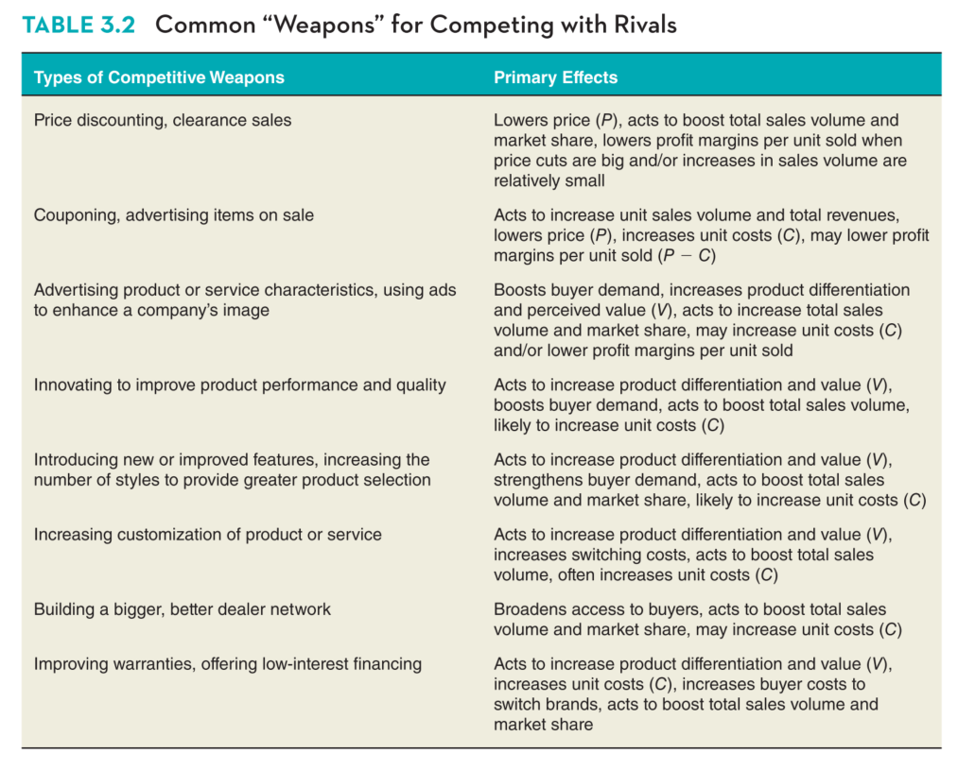

Competitive Pressure Associated with the Threat of New Entrants

* New entrants to a market bring new production capacity, the desire to establish a secure place in the market, and sometimes substantial resources.
* Entrant a market depends on two factors
  + Expected reaction of incumbent firms to new entry
  + Barriers to entry
* Defensive maneuvers maintains the firms’ position, and make it hard for new entrant to gain a sufficient market foothold to survive and eventually become profitable
* Most widely encountered barriers
  + Cost advantages enjoyed by industry incumbents
    - Existing industry members frequently have costs that are hard for a newcomer to replicate
    - Cost advantage
      * Scale economies in production distribution, advertising, or other activities
      * The learning-based costs savings that accrue from experience in performing certain activities such as manufacturing or new product development or inventory management
      * Cost-savings accruing from patents or proprietary technology
      * Exclusive partnerships with the best and cheapest suppliers of raw materials and components
      * Favorable locations
      * Low fixed costs because they have older facilities that have been mostly depreciated
    - The bigger cost advantages, the riskier it becomes for outsiders to attempt entry
  + Strong brand preferences and high degrees of customer loyalty
    - The stronger the attachment of buyers to established brands, the harder it is for a newcomer to break into the marketplace
    - Building brand recognition is important, but costly
    - Such barriers discourage new entry because they act to boost financial requirements and lower expected profit margins for new entrants.
  + Strong “network effects” in customer demand
    - Where buyers are more attracted to a product when there are many other users of the product, there are said to be “network effects”, since demand is higher than the larger the network of users.
    - When incumbents have a large existing base of users, new entrants with otherwise comparable products face a serious disadvantage in attracting buyers.
  + High capital requirements
    - The larger the total dollar investment needed to enter the market successfully, the more limited the pool of potential entrants.
  + The difficulties of building a network of distributors and deals and securing adequate space on retailer’s shelves
    - A potential entrant can face numerous distribution channel challenges
    - Potential entrants sometimes have to “buy” their way into wholesale or retail channels by cutting their prices to provide dealers and distributors with higher markups and profit margins or by giving them big advertising and promotional allowances
    - A potential entrant’s own profit may be squeezed unless and until its product gains enough consumer acceptance that distributors and retailers are anxious to carry it.
  + Restrictive government policies
    - Government agencies can also limit or even bar entry by requiring licenses and permits
    - Tariffs and trade restrictions
  + The strongest competitive pressures associated with potential entry frequently come not from outsiders but from current industry participants looking for growth opportunities.
  + The threat of entry changes as the industry’s prospects grow brighter or dimmer and dimmer and as entry barriers rise or fall.

Competitive Pressures form the sellers of substitute products

* The pressures from substitute products depends on three factors
  + Whether substitutes are readily available and attractively priced
    - The presence of readily available and attractively priced substitutes creates competitive pressure by placing a ceiling on the price industry members can charge
    - This price ceiling, at the same time, puts a lid on the profits that industry members can earn unless they find ways to cut costs
  + Whether buyers view the substitutes as being comparable or better in terms of quality, performance, and other relevant attributes
    - The availability of substitutes inevitably invites customers to compare performance, features, ease of use, and other attributes as well as price.
  + Whether the costs that buyers incur in switching to the substitutes are low or high
    - Low switching costs make it easier for the sellers of attractive substitutes to lure buyers to their offerings
    - High switching costs deter buyers from purchasing substitute products
  + How to identify substitute
    - Determining where the industry boundaries lie
    - Figuring out which other products or services can address the same basic customer needs as those produced by industry members
    - Deciding on the industry boundaries is necessary for determining which firms are direct rivals and which produce substitutes
      * There are no hard-and-fast rules, other than to say that other brands of the same basic product constitute rival products and not substitutes
  + Lower the price of substitutes, the higher their quality and performance; and the lower the user switching costs ,the more intense the competitive pressures posed by substitute products
  + Other indicators of competitive strength
    - Whether the sales of substitutes are growing faster than the sales of the industry being analyzed
    - Whether the producers of substitutes are moving to add new capacity
    - Whether the profits of the producers of substitutes

Competitive pressure stemming from supplier bargaining power

* Determine the strength
  + Whether demand for suppliers’ products is high and they are in short supply
    - Suppliers of items in short supply have pricing power, whereas a surge in the available supply of particular items shifts the bargaining power to the industry members
  + Whether suppliers provide a differentiate input that enhances the performance of the industry’s product
    - The more valuable input is in terms of enhancing the performance or quality, the more bargaining leverage suppliers have
    - The suppliers of commodities are in a weak bargaining position, since industry members have no reason other than price to prefer one supplier over another
  + Whether it is difficult or costly for industry members to switch their purchases from one supplier to another
    - Low switching costs limit supplier bargaining power by enabling industry members to change suppliers if any one supplier attempts to raise prices by more than the costs of switching
    - The higher the switching costs of industry members, the stronger the bargaining power of their suppliers
  + Whether the supplier industry is dominated by a few large companies and whether it is more concentrated than the industry it sells to
    - Suppliers with sizable market shares and strong demand for the items they supply generally have sufficient bargaining power to charge high prices and deny requests from industry members for lower prices or other concessions.
  + Whether suppliers provide an item that accounts for a sizable fraction of the costs of the industry’s product
    - The bigger the cost, the more industry members will be sensitive to the actions of suppliers to raise or lower their prices. As a result, they will bargain more aggressively
  + Whether it makes good economic sense for industry member to integrate backward and self-manufacture items they have been buying from suppliers
    - When industry members can threaten credibly to self-manufacture suppliers’ goods, their bargaining power over suppliers increases proportionately
  + Whether there are good substitutes available for the suppliers’ products
    - The better the price and performance characteristics of the substitute inputs, the weaker the bargaining power of suppliers
  + Whether industry members are major customers of suppliers
    - suppliers have less bargaining leverage when their sales to members of the industry constitute a big percentage of their total sales
  + identify the degree of supplier power in an industry
    - identify the different types of suppliers
    - paying particular attention to those that provide the industry with important inputs
    - access the bargaining power of each type of supplier separately

Competitive pressures stemming from buyer bargaining power and price sensitivity

* whether buyers are able to exert strong competitive pressures on industry members depends on
  + the degree to which buyers have bargaining power
  + the extent to which buyers and price-sensitive
* buyers with strong bargaining power can limit industry profitability by
  + demanding price concessions
  + better payment terms
  + additional features and services that increase industry members’ costs
* individual customers’ bargaining power varied by their individual preference
* business buyers can have considerable bargaining power
* retailers tend to have greater bargaining power over industry sellers if they have influence over the purchase decisions of the end user or if they are critical in providing sellers with access to the end user
* Determine the bargaining power
  + Buyer power increases when buyer demand is weak in relation to industry supply
  + Buyer power increases when industry goods are standardized or differentiation is weak
  + Buyers’ bargaining power is greater when their costs of switching to competing brands or substitutes are relatively
  + Buyers have more power when they are large and few in number relative to the number of sellers
  + Buyers gain leverage if they are well informed about sellers’ products, prices, and costs
  + Buyers bargaining power is greater when they pose a credible threat of integrating backward into the business of sellers
  + Buyer leverage increases if buyers have discretion to delay their purchases or perhaps even not make a purchase at all
  + Buyer price sensitivity increases when buyers are earning low profits or have low income
  + Buyers are more price-sensitive if the product represents a large fraction of their total purchases
* Not all buyers of an industry’s product have equal degrees of bargaining power with sellers